

**Derivation of Fourier Transform**

**& Image De-Noising Application**

**Group3 members:**

**柯煜华 1930026060 (Derivation of FT Series & Transform)**

**薛劭杰 1930026143 (DFT & FFT** **Implementation )**

**唐仲一 1930026115 (De-Noising & Filter Analysis)**

**吴楚瑜 1930026127 (De-Noising & Results Analysis)**

Content

Abstract 2

Theoretical Derivation of FT 2

Application in Image De-Noising 10

De-Nosing Results Analysis 18

Reference 24

# Abstract

Report contains the theoretical derivation of Fourier series, analysis of discrete Fourier transforms and fast Fourier transforms, brief introduction of general filter in terms of de-noising, implementation of Gaussian lowpass filter and Butterworth lowpass filter in MATLAB (to perform denoising) and filters evaluation. We performed an experiment and found that 100 is the optimal Cutoff frequency within the experimented range (30-150). Afterwards, 3 different kinds of noise are added to one image and visual effects as well as PSNR are involved to measure the effect of the denoising filters.

# Theoretical Derivation of FT

**Derivation --- Orthogonality of Trigonometric**

For any pair of orthogonal vectors (a and b), they must satisfy $a ∙b=\sum{a_{i}b_{i}=0}$.

Assume we have a trigonometric function:

$$f\left(x\right)=cos⁡(nx)$$

Multiply both side with $\sin{mx}$, we get:

$$\cos{mx}f\left(x\right)=\cos{nx}\cos{mx}$$

Find the integral of both sides in the interval $[-π,π]$, and use product to sum formular to simplify the expression:

$$\int_{-π}^{π}{\cos{nx}\cos{mx}dx=}\int_{-π}^{π}{\frac{1}{2}[cos⁡[\left(n-m\right)x]+cos⁡[\left(n+m\right)x]]}$$

$$→\frac{1}{2}×\frac{1}{n-m}\int_{-π}^{π}{ \sin{[\left(n-m\right)}x]dx}+\frac{1}{2}×\frac{1}{n+m}\int_{-π}^{π}{ sin[\left(n+m\right)x]dx}$$

For $f\left(x\right)=\sin{nx}$, the procedures are the same.

Since trigonometric functions are symmetric function, which means the integral of the product of trig functions of different frequency within a period equals to zero. Hence, we have proved the orthogonality of trigonometric.

**Derivation --- Fourier Series**

According to a theorem, a periodic signal can be expanded to Fourier series if it satisfies the Dirichlet conditions. Besides, the definition of Dirichlet conditions is:

1. Within a period, the signal is continuous or contains discontinuity point of the first kind.
2. Within a period, the number of maximal / minimal values are limited.
3. Within a period, the signal is absolute integrable.

Thus, define a function

$$f\left(t\right)=c_{0}+\sum_{1}^{∞}{c_{n}cos⁡(nωt+φ)}$$

By using product to sum formular

$$f\left(t\right)=c_{0}+\sum_{n=1}^{∞}{c_{n}\cos{φ}\cos{nωt}}-\sum_{n=1}^{∞}{c_{n}\sin{φ}\sin{nωt}}$$

Define $a_{n}=c_{n}\cos{φ},b_{n}=-c_{n}\sin{φ}$ and substitute it into $f(t)$

$$f\left(t\right)=c_{0}+\sum_{n=1}^{∞}{a_{n}\cos{nωt}}+\sum_{n=1}^{∞}{b_{n}\sin{nωt}}$$

The above expression has the same form as Fourier series, thus next we are going to find the value of $a_{n},b_{n}$. First, multiple two sides by $sin⁡(kωt)$, and calculate the integral of a period of both sides.

$$\int_{0}^{T}{f\left(t\right)\sin{kωt} dt}=\int_{0}^{T}{c_{0}\sin{kωt} dt}+\int_{0}^{T}{\sin{kωt}\sum_{n=1}^{∞}{a_{n}\cos{nωt}}+\sum_{n=1}^{∞}{b_{n}\sin{nωt}} dt}$$

Since $\int_{0}^{T}{c_{0}\sin{kωx} dt}=0$, we can infer that $\int_{0}^{T}{a_{n}{\cos{ kωt }}\sin{kωt}dt}=0$, hence we can simplify the expression as:

$$\int_{0}^{T}{f\left(t\right)\sin{nωt} dt}=b_{n}\int_{0}^{T}{\sin{{\left(nωt\right)}^{2}} dt}=\frac{b_{n}T}{2}$$

$$→b_{n}=\frac{2}{T}\int_{0}^{T}{f\left(t\right)\sin{nωt} dt}$$

Similarly

$$a_{n}=\frac{2}{T}\int_{0}^{T}{f\left(t\right)\cos{nωt} dt}$$

**Derivation --- Complex function to Fourier Series**

Euler formular: $e^{iθ}=\cos{θ}+i\sin{θ}$, this formular connects complex number, exponential function and trig function together.

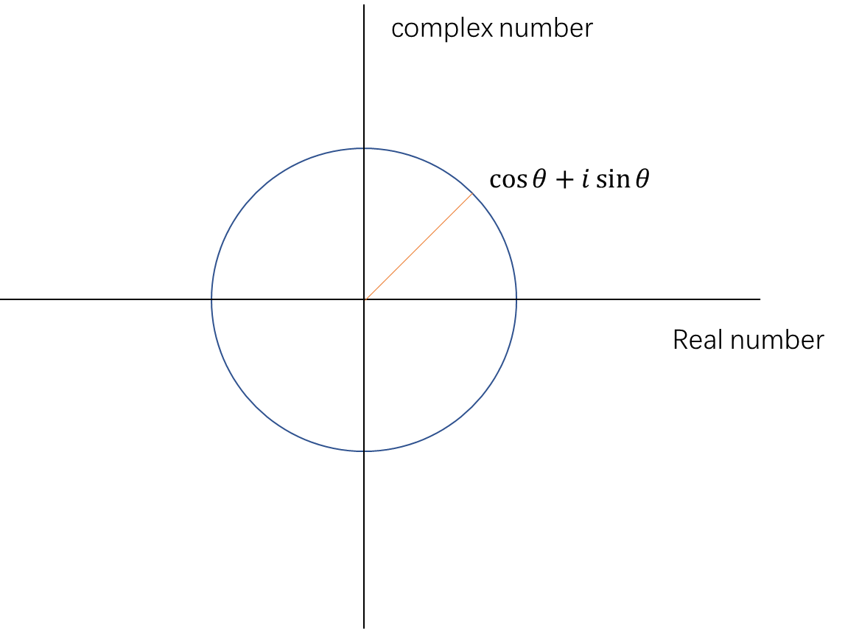

Since $θ=ωt=\frac{2π}{T}t$, we can treat complex function as a track of a point (angular speed: $ω$, period: $T$) that rotates around the origin. And then, we substitute $θ$ into previous expression.

$$e^{iωt}=\cos{ωt}+i\sin{ωt}$$

Assume there is a group of trig function, whose frequency is n times of $\cos{ωt}$, we can define this set of trig metrics as:

$$\cos{nωt}=\frac{e^{inωt}+e^{-inωt}}{2}$$

$$\sin{nωt}=\frac{e^{inωt}+e^{-inωt}}{2i}$$

And then, substitute it back to $f\left(t\right)=c_{0}+\sum_{n=1}^{∞}{a_{n}\cos{nωt}}+\sum_{n=1}^{∞}{b_{n}\sin{nωt}}$ we get

$$f\left(t\right)=c_{0}+\sum_{n=1}^{∞}{a_{n}\frac{e^{inωt}+e^{-inωt}}{2}}+\sum_{n=1}^{∞}{b_{n}\frac{e^{inωt}+e^{-inωt}}{2i}}$$

$$→f\left(t\right)=c_{0}+\sum_{n=1}^{∞}{(\frac{a_{n}-ib_{n}}{2}e^{inωt}+\frac{a_{n}+ib_{n}}{2}e^{-inωt})}$$

And since

$$b_{-n}=\frac{2}{T}\int_{0}^{T}{f\left(t\right)\sin{-nωt} dt}$$

$$a_{-n}=\frac{2}{T}\int_{0}^{T}{f\left(t\right)\cos{-nωt} dt}$$

We can rewrite $f(t)$ as:

$$f\left(t\right)=c_{0}+\sum_{n=1}^{∞}{(\frac{a_{n}-ib_{n}}{2}e^{inωt}+\frac{a_{-n}-ib_{-n}}{2}e^{-inωt})}$$

$$→f\left(t\right)=c_{0}+\sum_{n=1}^{∞}{(\frac{a_{n}-ib_{n}}{2}e^{inωt})}+\sum_{n=-∞}^{-1}{(\frac{a_{n}-ib_{n}}{2}e^{-inωt})}$$

And as $c_{0}$ represent the situation when frequency equals to zero

Define $A_{n}=\frac{a_{n}-ib_{n}}{2}$, we simplify the expression into $f\left(t\right)=\sum_{-∞}^{∞}{A_{n} e^{inwt}}$, which is Fourier series.

Multiply both sides with $e^{-ikwt}$ and calculate the integral, we have:

$$\int_{0}^{T}{f\left(t\right)e^{-inwt} dt}=\sum_{-∞}^{∞}{A_{n} e^{i(n-k)wt}dt}$$

When $n≠k$, the result of integral is zero, when $n=k$, we have:

$$\int_{0}^{T}{f\left(t\right)e^{-inwt} dt}=A_{n}T$$

$$→A_{n}=\frac{1}{T}\int_{0}^{T}{f\left(t\right)e^{-inwt} dt}$$

Hence, the Fourier Series is:

$$f\left(t\right)=\sum_{-∞}^{∞}{A_{n} e^{inwt}}=\sum_{-∞}^{∞}{(\frac{1}{T}\int_{-\frac{T}{2}}^{\frac{T}{2}}{f\left(t\right)e^{-inwt} dt}) e^{inwt}}$$

And then we expand it for aperiodic function:

$$f\left(t\right)=\sum_{-∞}^{∞}{C_{n} e^{inw_{0}t}}=\frac{1}{2π}\int_{-∞}^{∞}{\int_{-∞}^{∞}{f\left(t\right)e^{-iwt}} dt}$$

Finally, we obtain

$$F\left(w\right)=\int_{-∞}^{∞}{f\left(t\right)e^{-iwt}} dt (Fourier Transform)$$

$$f(t)=\frac{1}{2π}\int_{-∞}^{∞}{F\left(w\right)e^{iwt}dw}(Inverse Fourier Transform)$$

**Discrete Fourier Transform (DFT)**

Because it is difficult for computers to process continuous data, we require discrete Fourier transform. For continuous Fourier transform, do equidistant N sampling within the period. We can set the $f(t)$ is equidistant sampling in one period. For each period, the definition function can be expressed by: $f\left(t\right)→\left[f_{0},f_{1},f_{2},……, f_{N-1}\right]$, where $f_{K}=f(K\frac{T}{N})$.

For the Fourier Series function, each point can be calculated by:

$f\left(\frac{T}{N}\right)=\sum_{-∞}^{∞}{e^{n\frac{iwT}{N}}}=…+C_{-2}e^{-2\frac{iwT}{N}}+C_{-1}+e^{-1\frac{iwT}{N}}+…+C_{N-1}e^{-\left(N-1\right)\frac{iwT}{N}}+C_{N} e^{-N\frac{iwT}{N}}+C_{N+1}e^{-(N+1)\frac{iwT}{N}}+…$

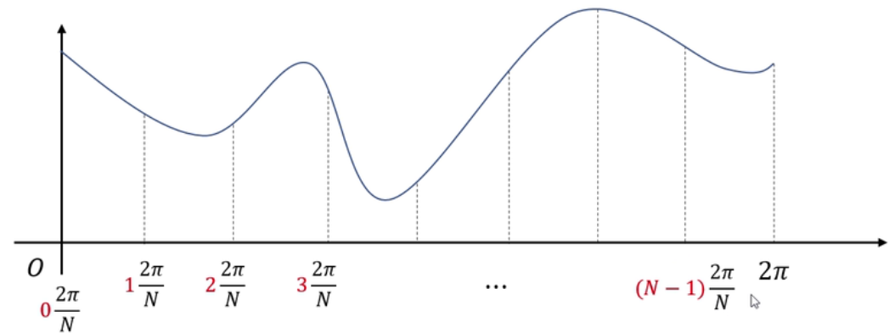

For $e^{n\frac{iwT}{N}}$, it can be show as following. A point returns to its original position after every cycle. We can use a coordinate system diagram to express it.

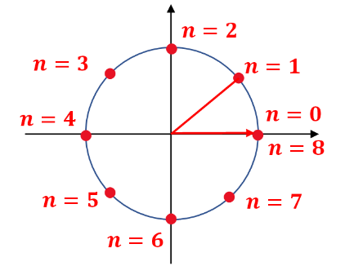

$$The complex graph for T=2π, N=8$$

$K=1, f\left(\frac{2π}{N}\right)=\left(C_{0}+C_{N}+C_{-N}+C_{2N}+C_{-2N}+…\right)*e^{\frac{0\left(2πi\right)}{N}}+\left(C_{1}+C_{N+1}+C_{-N+1}+C_{2N+1}+C_{-2N+1}+…\right)*e^{\frac{1\left(2πi\right)}{N}}+…+\left(C_{-1}+C_{N-1}+C_{-N-1}+C_{2N-1}+C_{-2N-1}+…\right)$ $e^{\frac{(N-1)\left(2πi\right)}{N}}$

*

Let $w^{k}=e^{k\frac{2πi}{N}}$. In a similar way, we can calculate all the result for $K=2 to K=N-1$. As a result, we can get $N-1+1=N$ groups and show it in a matrix:

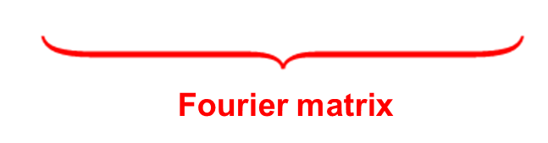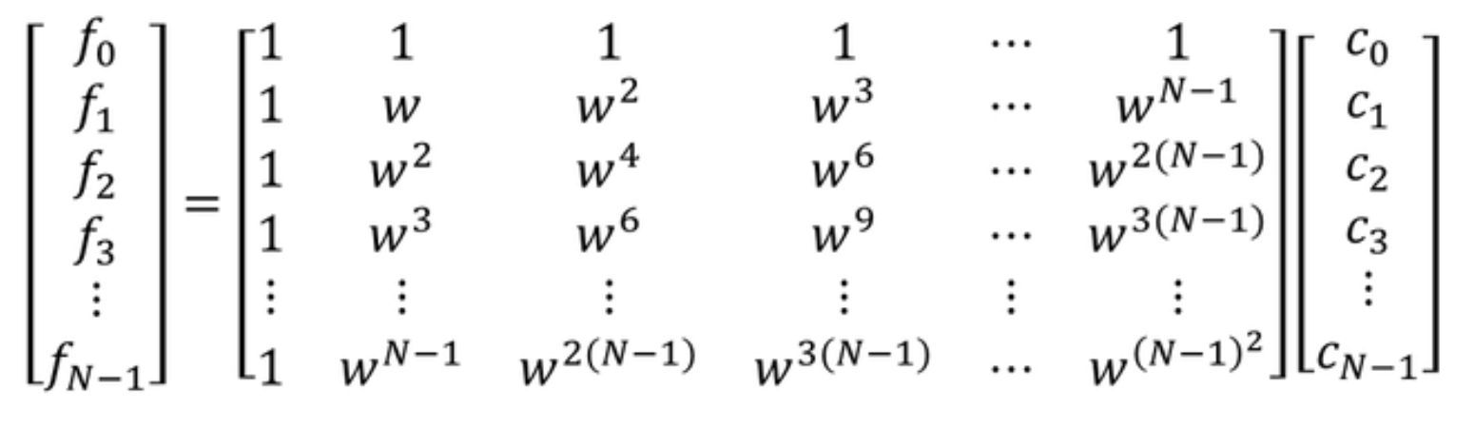

From the $vector f$ to the $vector c$, it is called Discrete Fourier Transform. And the $ω$ matrix is called Fourier matrix. To conclude, we have:

1. For discrete points, we cannot use the definite integral to do the transform.
2. Discrete data in a function after DFT is still discrete.

**Generalize to two dimensions**

Do DFT on one dimension and then do transform on the other dimension:

$Step1. f\left(x,y\right)→DFS→F(x,v)=\frac{1}{N}\sum_{0}^{N-1}{f\left(x,y\right)e^{-v*\frac{2πyi}{N}} }$

$Step2. F\left(x,v\right)→DFS→F(u,v)=\frac{1}{M}\sum_{0}^{M-1}{F\left(x,v\right)e^{-u*\frac{2πxi}{M}} }$

$Result: f\left(x,y\right)→F(u,v)$

**Problem of DFT**

When the time span of the function or domain of definition is very large, it will generate a large matrix which may cost high complexity to Work out the result.

And we can analyze the flops before handling with FFT:

For n rows, there are $n$ square multiplications and $n^{2}-n$ additions are required. Totally, it takes $2n^{2}-n$ flops. So we should reduce cost by the time of inner product.

**Principle of FFT**

In order to solve the Problems of DFT, calculation can be reduced by Using some linear algebra skills. $Vector c$ can be derived by the following formula. Here is a little difference from the above one. The hat of the $ω$ is the conjugate of $ω$. $w^{k}=e^{k\frac{2πi}{N}}→{\overline{w}}^{k}=e^{-k\frac{2πi}{N}}$**.**

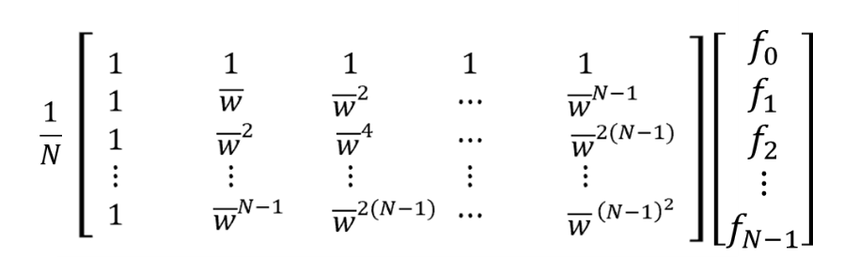

Let the original Fourier matrix be $W_{N}$, then we have this property

$W_{N}W_{N}^{*}=N\left[\begin{matrix}1 & 0 & 0 \\ 0 & ⋱ & 0 \\ 0 & 0 & 1\end{matrix}\right]→W_{N}^{-1}=\frac{1}{N}W_{N}^{*}$,where $'*'$ means conjugate matrix.

Take the $N=4$ matrix as an example:

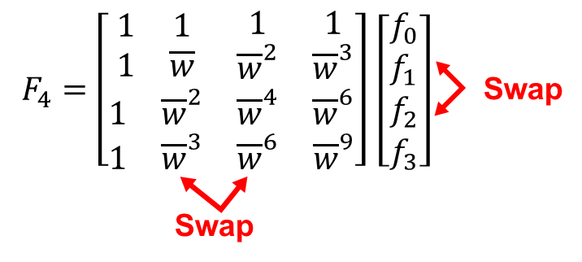 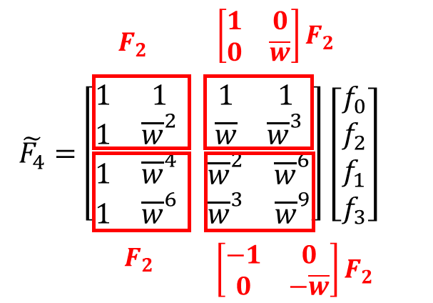

$- Step1.$ Swap the odd and even columns in the matrix $F_{4}^{*}$, swap the odd and even rows of the vector $f$. The position has changed, but the final product is the same.

$- Step2.$ Name the new matrix $\tilde{F_{4}}$ and set the matrix block in the upper left to $F_{2}$. Combine with the complex graph, the values of the conjugate of $w$ are symmetric according to the x-axis. So, the other block can be expressed by the $F_{2}$ just like the above graph.

$- Step3.$ Generalize the case to larger $2^{N}$ matrix:

$F_{2N}=\left[\begin{matrix}F_{N} & D_{N}F_{N} \\ F_{N} & -D_{N}F_{N}\end{matrix}\right]$**where $D_{N}=\left[\begin{matrix}\begin{matrix}1 & 0 \\ 0 & \overline{w}\end{matrix} & \begin{matrix}0 & 0 \\ 0 & 0\end{matrix} \\ \begin{matrix}0 & 0 \\ 0 & 0\end{matrix} & \begin{matrix}⋱ & 0 \\ 0 & {\overline{w}}^{N-1}\end{matrix}\end{matrix}\right]$**

Simplify the formula and we can analyze the new flops:

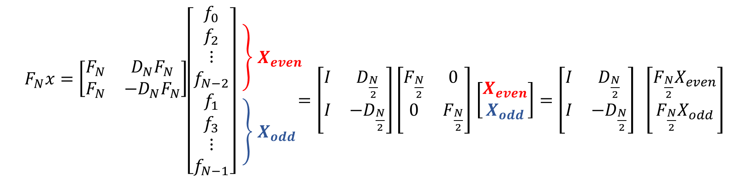

$1. F_{\frac{N}{2}}X_{even}$ takes $\frac{n}{2}*\frac{n}{2}=\frac{n^{2}}{4}$ multiplication.

$2. {F_{\frac{N}{2}}X}_{odd}$ takes $\frac{n}{2}*\frac{n}{2}=\frac{n^{2}}{4}$ multiplication.

1. $I$ (identity matrix) $and D_{\frac{N}{2}}$ are diagonal matrices, takes n times multiplication.

$Totally, it just take \frac{n^{2}}{2}+n multiplication$, it reduces about half of the products. Therefore, it must product the reduce faster than before absolutely.

**Code details of FFT:**

* Function FFT_2d is used to do the Edge detection and some basic processing for the image suach as grey-scale map transformer and separating dimensions
* Function FFT_1d is used to define sampling frequency and generate the Fourier matrix. Especially, we need to pay attention to the calculation of the complex part and the judgement of demension.

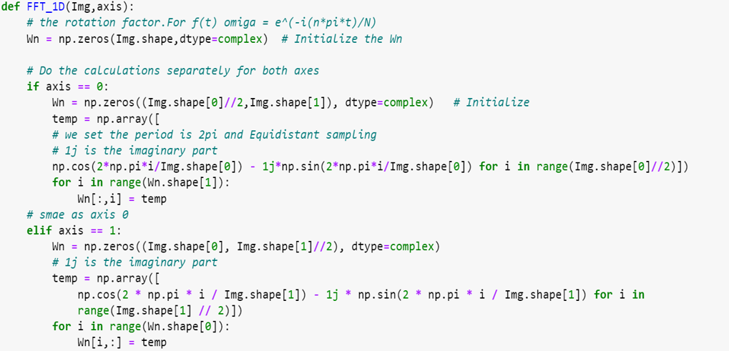

* Function FFT is the core for this program, it is also a concrete manifestation of the FFT principle. Firstly, swap the odd and even columns and row for the matrix $W_{n}$ and verctor $f$ (image shape) respectively. Then keep recursion to divide the Fourier matrix and each time it should calculate the value of $-Dn*Fn$ and $I*Fn$. When the shape of matrix reduce to the $2*2$, then it meets the base case for the recursion and calculate the result and return it.

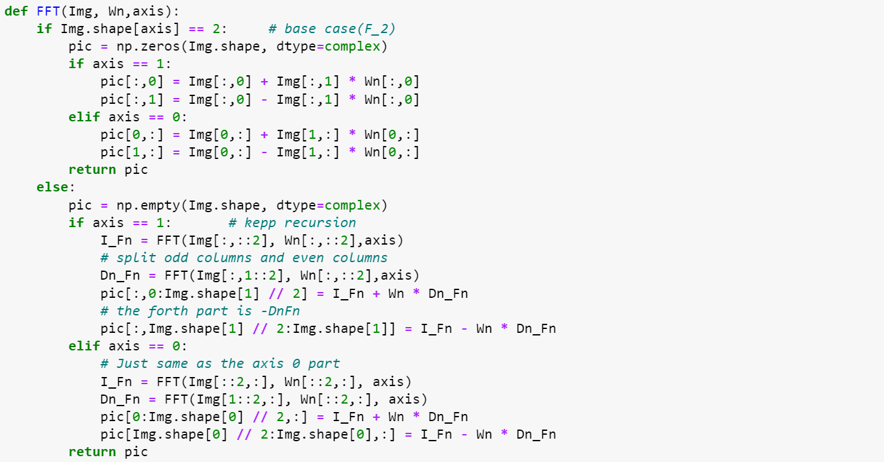

Take a large matrix and you recursively evaluate the submatrices.

Execute the program & Test the result:

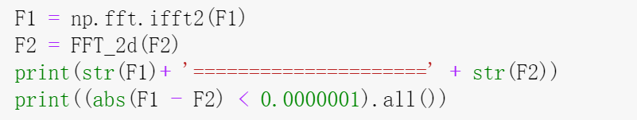

The left picture shows the $F_{1}$ which is producted by the package in library, and the right part is the result generated by the our program. Obviously, the result is same which means the our FFT code is correct. The printed result is the value in the frequency domain.

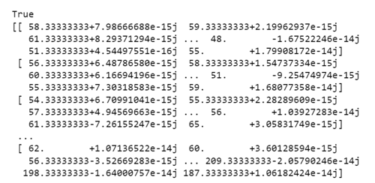 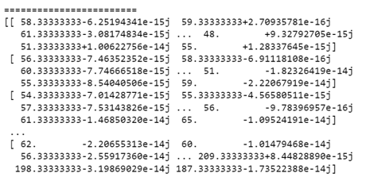

# Application in Image De-Noising

**The motivation of de-noising**

Nowadays, images, which has large amount of information, are an important way for people to acquire knowledge, but in the process of digitalization and transmission, the digital image is often affected by the noise of imaging equipment and external environment. In order to eliminate noise, people need to de-noise the image.

**Two general filters for de-noise**

**Filters in space domain**

The methods for removing noise in images includes methods based on the space domain, like mean filter, median filter, wiener filter and so on. De-noising methods in the space domain usually carry out operations directly on the pixels in the picture, like mean filter and median filter, they modify a particular pixel’s value based on the neighbor pixels’ mean value or median value (neighbor pixels usually are the $n×n$ pixels whose center is the pixel that we are currently focus on). From a higher perspective, filters that de-noise in space domain like mean filter and median filter use a kernel, a $n×n$ matrix to perform the calculation of convolution on the whole picture. The following picture shows the principle of mean filter.

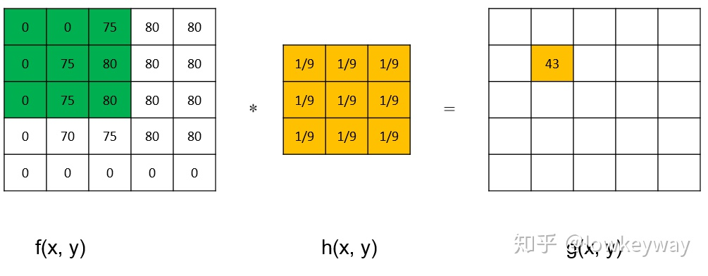

**Filters in frequency domain**

There’re also methods based on the frequency domain, like Gaussian lowpass filter and Butterworth lowpass filter. In our project we mainly focus on filters that de-noise in the frequency domain. Filters in frequency domain needs to modify the original picture with noise by changing the frequency of the picture, in order to obtain the frequency of the picture, we must apply Fourier transform to the picture that we about to process. After applying Fourier transform, we can modify the frequency of the pictures so as to remove noise. Later when discussing Gaussian lowpass filter and Butterworth lowpass filter, we will talk more in depth about the de-noise procedure.

**Lowpass filter**

Once applied Fourier transform, we obtain the frequency of the image, the low frequency of the image represents the part of the image that is smoother, whereas the high frequency part of the image stands for the edge of the image or the noise. In order to eliminate the noise in the image, we need to implement filters that can filter out the higher frequency part, which stands for the noise, from the image. Therefore, we implement lowpass filter to filter out the high frequency from the image.

When we do lowpass filtering, we will firstly apply Fourier transform to get the frequency of the image, then the lowpass filter can keep out all the high frequency part of the image to remove the noise from the image as well as make the image smoother. Then we apply inverse Fourier transform to obtain the image without noise.

In our project, we implement 2 lowpass filter, which are Gaussian lowpass filter and Butterworth lowpass filter.

**Gaussian lowpass filter**

The first lowpass filter that we implement is the Gaussian lowpass filter, in this part, we will illustrate how did we implement the Gaussian lowpass filter in MATLAB. We set the cutoff frequency to be 30 at the first place, we will further investigate the choice of cutoff frequency and the result of denoising in later steps. Then we store the size of the image to 2 variables in our function.

Then we apply Fourier transform to the image by using the embedded function $fft2(double(image))$ to obtain the frequency of the image. We should notice that we need to transfer the image to $double$ type in order to use the function $fft2()$. After that we further use the built-in function $fftshift(image)$ to shift the zero-frequency component to center of spectrum. Here are the MATLAB code for this part.

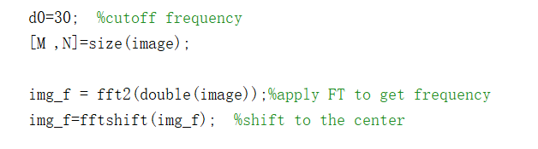

Then we also calculate the center’s coordinates for calculating distance later.

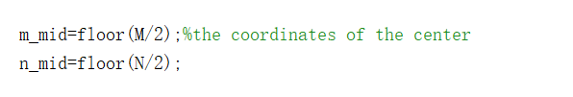

Then we need to construct a matrix in order to modify the frequency of the image. We firstly initialize the matrix to be the same size as the image’s size. Then we calculate the matrix’s value for each position in a nested for loop. Inside the loop we firstly calculate the distance between the current pixel to the center of the image then substitute the distance and the cutoff frequency that we set before into the transfer function of Gaussian lowpass filter to obtain the value in the $(i,j)$ position in the matrix.

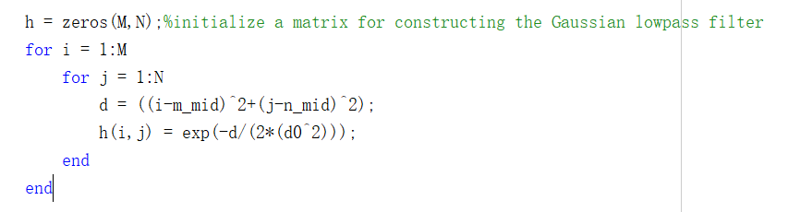

Following is the transfer function of the Gaussian lowpass filter

$$H\left(u,v\right)=e^{-\frac{d(u,v)}{2d_{0}^{2}}}$$

Where $(u,v)$ is the position of the matrix, $d$ represents the distance between $(u,v)$ and the center and $d_{0}$ stands for the cutoff frequency.

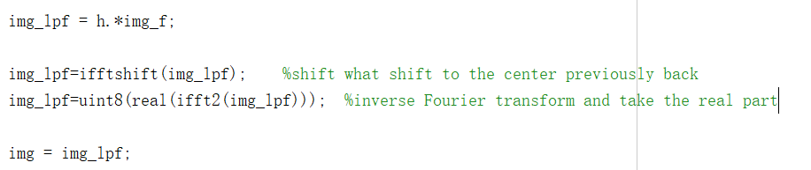

Then we can use the matrix that we construct to multiply the matrix representation of the frequency of the image. Once the multiplication is done, we can use the function $ifftshift(image)$ to shift back what we shift to center previously. Then we can further apply the inverse Fourier transform to the frequency to the matrix representation of the image’s frequency and we can get the image that after the process of de-noise.

Butterworth lowpass filter

The principle of Butterworth lowpass filter is somehow similar to the Gaussian lowpass filter, the main difference between them is the different transfer function that they apply when constructing the matrix.

Here’s the transfer function of Butterworth lowpass filter

$$H\left(u,v\right)=\frac{1}{\left(1+{\left(\frac{D\left(u,v\right)}{D_{0}} \right)}^{2n}\right)}$$

Then we will briefly explain the parameter of the transfer function. Here, $D(u,v)$ and $D_{0}$ are the same with the Gaussian lowpass filter, which are the distance between $(u,v)$ and the center and the cutoff frequency. The parameter $n$ represents how many times we apply the Butterworth lowpass filter on the image, in our project we set the value of $n$ to be 2.

Here is the MATLAB code for the Butterworth lowpass filter

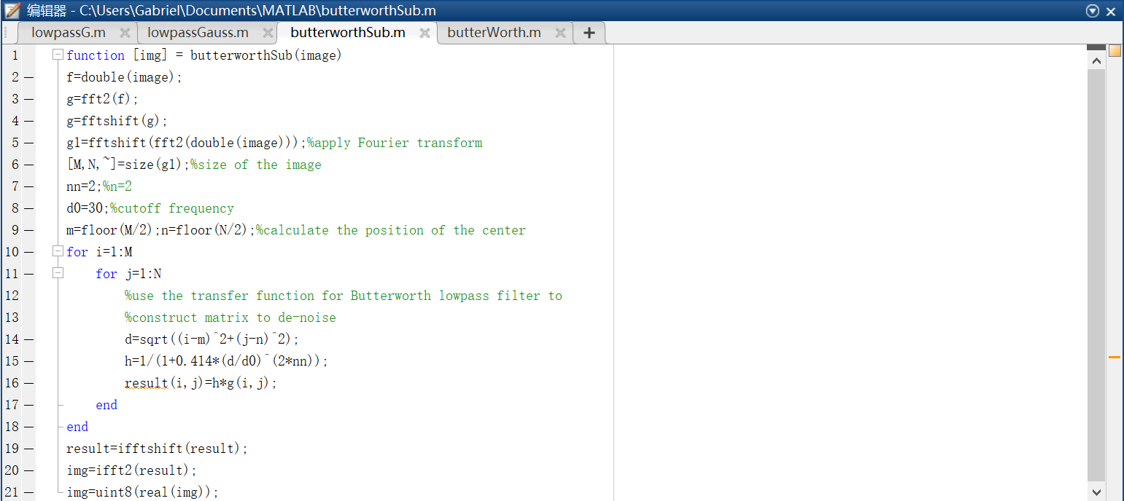

**Removing the noise in colored pictures**

Usually, we can only use filters on gray-scale image, we can’t directly apply the filters on color image. In order to eliminate the noise on color images, we can separate the image into 3 channels, which are red, green and blue, then we can apply the lowpass filters to the 3 channels respectively, after using filters on the 3 channels, we combine them together to retrieve the original picture without noise.

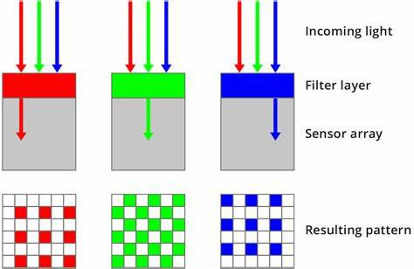

We will explain how did we de-noise in 3 channels respectively here. Firstly, we will read the image and add a certain type of noise that assigned by us. We use the Gaussian lowpass filter as an example here.

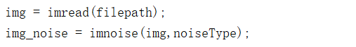

Then we separate the image with noise into 3 channels and apply the Gaussian lowpass filter to them respectively. Here the function $lowpassG(image)$ is the MATLAB function that constructed by us, we show the details of which in previous part of the report.

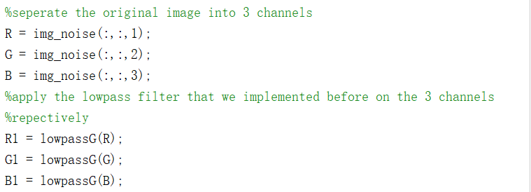

After using Gaussian lowpass filters we can combine the 3 channels together to obtain the color image without noise.

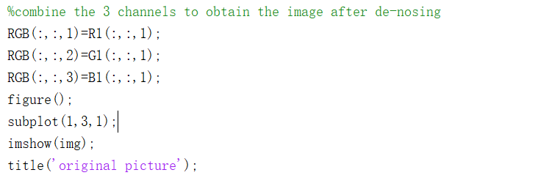

**The choice of the parameter cutoff frequency**

The parameter cutoff frequency needs to be decided by users and been used to construct the lowpass filter. Firstly, we set the cutoff frequency to be 30, in order to find out the optimal value of the cutoff frequency, we try the frequency value 30, 50, 70, 90, 110, 130, 150 and check their performance by comparing the image after de-noising to the original image. Here we use the Gaussian lowpass filter with the added noise to be “salt & pepper” noise for our test.

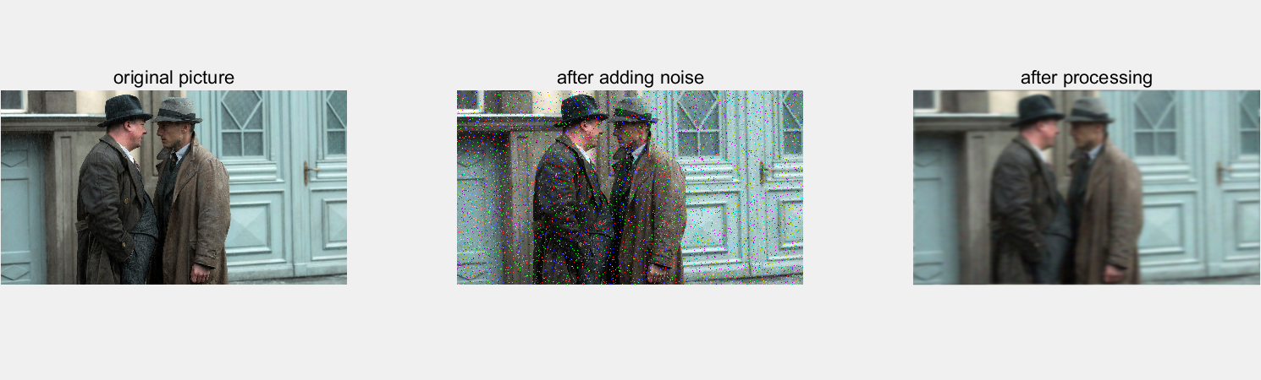

$$cutoff frequency=30$$

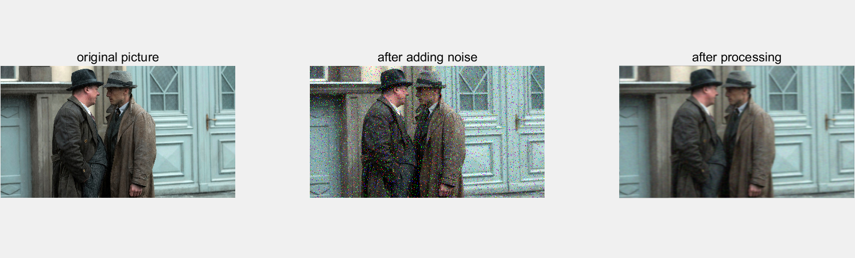

$$cutoff frequency=50$$

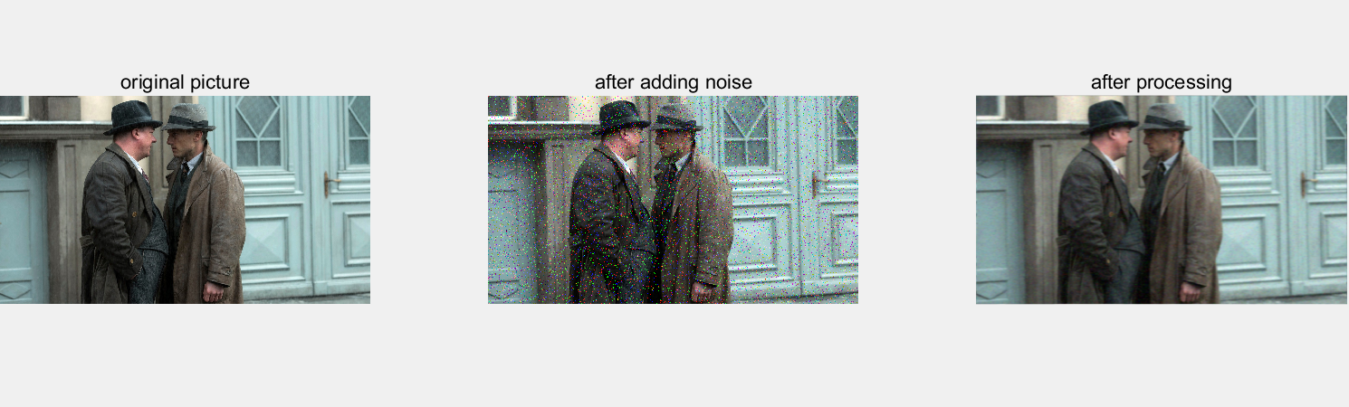

$$cutoff frequency=70$$

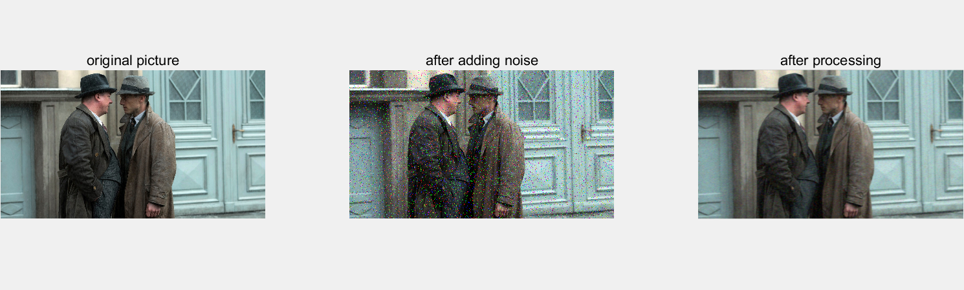

$$cutoff frequency=90$$

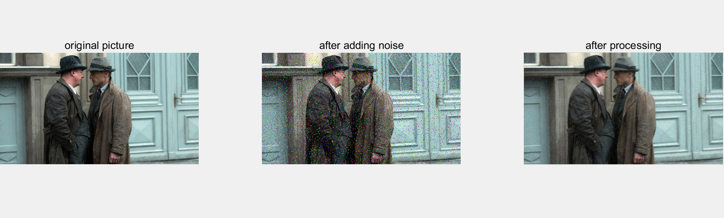

$$cutoff frequency=110$$

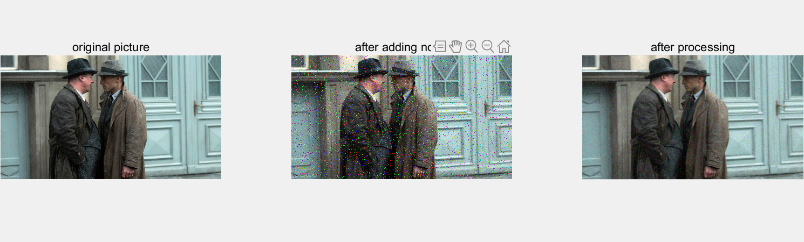

$$cutoff frequency=130$$

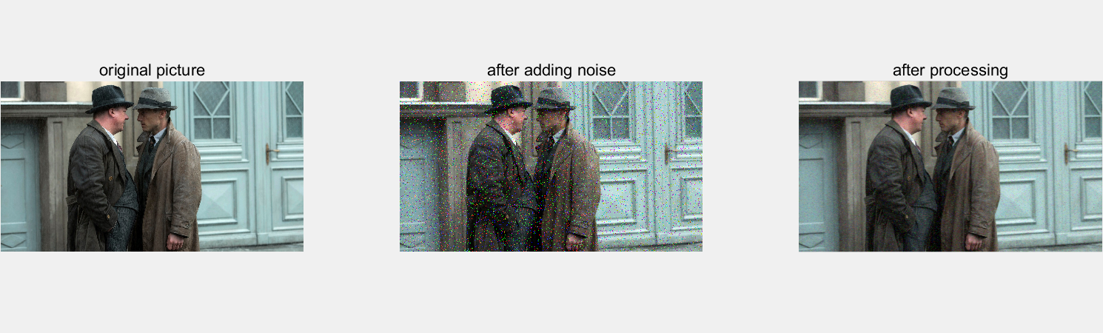

$$cutoff frequency=150$$

We can see that when the cutoff frequency equals to 30, there’s no salt & pepper noise that can be seen in the result image, however, the result image is blur too. In terms of the case when cutoff frequency equals to 150, the result image is not blur at all, but there’re some noise can be seen by human eyes. Then we interpreted that with the relative lower cutoff frequency the noise will be filtered out totally but the detail and edge of the image will also lose too. When the cutoff frequency is too high, the edge and details are preserved in a good fashion but there will be some noise that can’t filtered out. Based on the result images that we obtained, we conclude that 100 might be the optimal value in our case, since it can filter out most of the noise as well as not make the image blur.

In the next part we will evaluate the performance of Gaussian lowpass filter and Butterworth lowpass filter when different types of noise is added by showing the image after processing and calculate $PSNR$ scores to describe the performance of de-noise.

# De-Nosing Results Analysis

**Comparing Method**

In order to analyze the processing ability of two different filters we mentioned before, we will use this function of MATLAB to add different kinds of noise to a photo and compare the processing results.



The original image is from a TV show.



* Adding Salt and Pepper noise

In gray images, the noise is a random white or black dot, and in color images, the noise is isolated colored dots. The noise is usually caused by image sensors, transmission channels and so on.

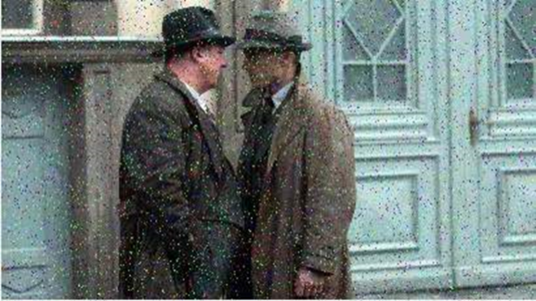

* Adding Gaussian noise

Gaussian noise is a kind of sensor noise, mainly due to the side effects of sensor heating. For Gaussian noise, the probability density function of noise conforms Gaussian distribution, that is, the number of noise of a certain intensity is the largest, and the farther away from this intensity, the fewer noise.

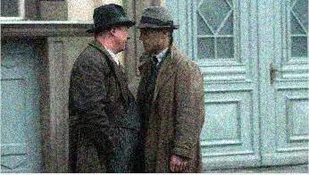

* Adding Speckle noise

Speckle noise is multiplicative noise, which usually caused by an unsatisfactory channel, and the noise changes with the signal.

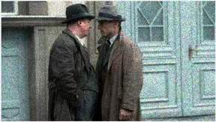

Besides, to compare the performance of two different filters, we conducted qualitative and quantitative evaluation experiments. Qualitative evaluation is using vision to observe the denoising ability of filtering for different noise. Quantitative evaluation mainly evaluates the denoising ability by comparing the value of peak signal to noise ratio (PSNR).

The peak signal to noise ratio is a commonly used indicator to measure signal distortion, which is calculated the value of image pixels. However, many experiments have shown that PSNR scores do not exactly match the visual effect seen by the human eye. This is because the sensitivity of human vision to error is not absolute, it will be affected by many factors.

The computing method of PSNR is:

$$PSNR=10\lg\left(\frac{2^{l}-1}{MSE}\right)$$

$$MSE=\frac{1}{MN}\sum_{i=1}^{M}{\sum_{j=1}^{N}{{[a\left(i,j\right)-\hat{a\left(i,j\right)}]}^{2}}}$$

MSE is the mean square error between 2 images, $a\left(i,j\right)$ and $\hat{a\left(i,j\right)}$ are the gray value or color value in the original image and color image respectively, M, N is the number of pixels of $M×N$ image. In MATLAB, there is already have function to directly calculate the value of MSE.

In PSNR, l is he color depth, which means the number of binary digits occupied by a pixel, usually people will take l=8, and we do this, too.

So, the higher the PSNR value, the smaller difference between two images. And in this paper, we calculate the PSNR value between the images adding the noise and the noised images after filtering. As the results, the smaller the PSNR value, the bigger difference between denoised images and the images with noise, which is the effect of denoising is more significant.

**Conclusion**

* Guassian lowpass filter

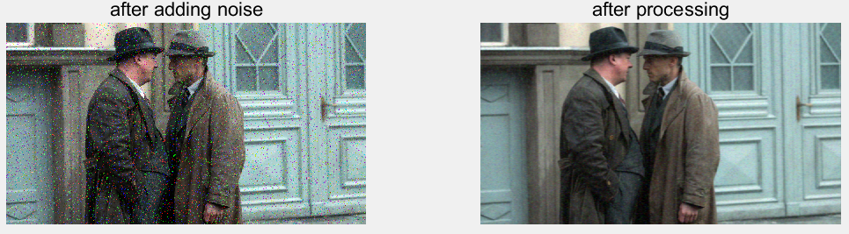

Salt and Pepper noise

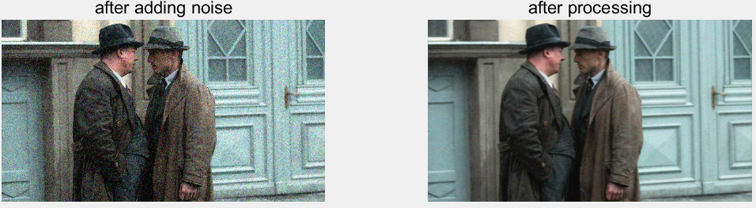

Gaussian noise

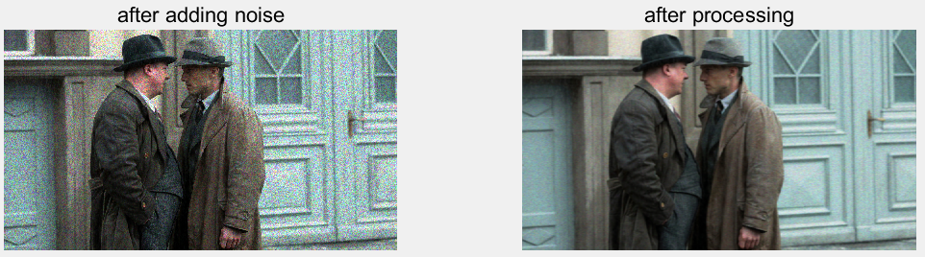

Speckle noise

|  |  |  |  |
| --- | --- | --- | --- |
|  | **Salt & Pepper Noise** | **Gaussian Noise** | **Speckle Noise** |
| **PSNR** | 24.2529 | 23.5834 | 23.2055 |

For the Gaussian lowpass filter, compare with the pictures with noise and the pictures processed by filter, this filter can indeed remove some noise and make the pictures smooth. Although the difference between different noise processed by filter may not be visible to our eyes, according to the different values before and after de-noising, it can be concluded that the filter will bring different results to different noise.

* Butterworth lowpass filter

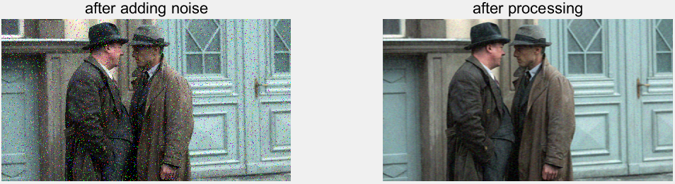

Salt and Pepper noise

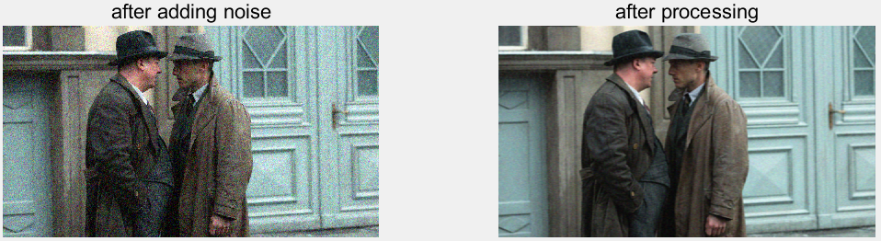

Gaussian noise

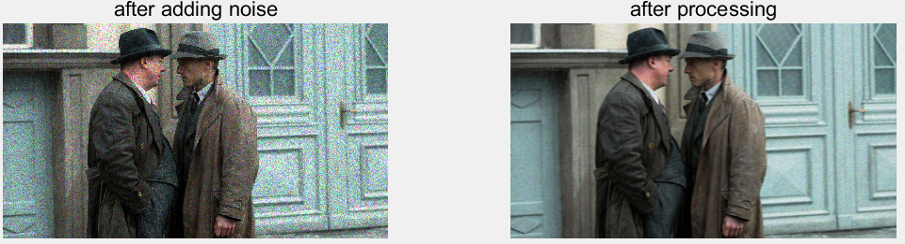

Speckle noise

|  |  |  |  |
| --- | --- | --- | --- |
|  | **Salt & Pepper Noise** | **Gaussian Noise** | **Speckle Noise** |
| **PSNR** | 24.2577 | 23.5883 | 23.2104 |

And for Butterworth lowpass filter, the results are similar, the difference between different noise processed by filter may not be visible to our eyes, and according to the values of PSNR, this filter also brings different results to different noise.

Comparing with these two filters, as for these three kinds of noise, the difference is not significant in visual, but based on the values of PSNR, in general, the Gaussian lowpass filter’s values are higher, so the filtering ability of Gaussian lowpass filter is stronger than Butterworth lowpass filter.

Also, for different noise types, the effect of these two filters on Speckle noise is more significant, and denoising ability for Gaussian noise and Salt and Pepper noise decreases respectively.

**Future**

In our experiment, although it can be concluded that two filters will have different denoising effect for different noise, through the eye observation and quantitative indicators, the difference is not great. Therefore, using a large number of different photos to observe the denoising effect may obtain a more reliable and general denoising conclusion to be applied to the real image denoising.

Besides, in practical application, we should make clear the noise type of the image and the degree of influence by noise before processing the noise image, so as to select the appropriate filtering technology and reduce the blindness of image denoising.

# Reference

[1] YANG Li-juan. et al. (2004). Fast Fourier transform and its applications. Opto-Electronic Engineering, 31

[2] NING Yuan. et al. (2005). Analysis and Comparison of Some Techniques on Image Denoising. JOURNAL OF GUIZHOU UNIVERSITY OF TECHNOLOGY(Natural Science Edition), 34(4)

[3] Brigham, E.O.(1988). The fast Fourier transform and its applications. Prentice-Hall, Inc.

[4] Sifuzzaman, M., Islam, M. R., & Ali, M. Z. (2009). Application of wavelet transform and its advantages compared to Fourier transform.